**Title**: Can Intrinsic Cortical Neurophysiology Serve as a Diagnostic Biomarker for Parkinson’s disease and Related Conditions?

Keeran Maharajh, Ph.D.,1 Isabelle Buard, Ph.D.,2 Johanna Shattuck, M.S.,3 Benzi M. Kluger, M.D., M.S.2\*

1 Department of Psychiatry, University of Colorado Anschutz Medical Campus, Aurora, CO

2 Department of Neurology, University of Colorado Anschutz Medical Campus, Aurora, CO

3 Department of Psychology, University of Nebraska, Lincoln, NE

\* Address correspondence and reprint requests to:

Dr. Benzi M. Kluger

Department of Neurology, University of Colorado Denver

Mail Stop B-185, 12631 East 17th Avenue

Aurora, CO 80045

Phone: (303) 724-2194

Fax: (303) 724-2212

E-mail: [benzi.kluger@ucdenver.edu](mailto:benzi.kluger@ucdenver.edu)

**Keywords:** Parkinson’s disease; Essential Tremor; Magnetoencephalography; Biomarker

**Abstract Word Count**: XXX

**Word Count**: xxx

**ABSTRACT**

Parkinson’s disease (PD)

**INTRODUCTION**

* Significance of PD; Need for biomarker; Limitation of current approaches
* Neurophysiology of PD; potential of neurophysiology to provide biomarker; review of Stam and other papers in this direction
* Objectives of current study:
  + Determine whether MEG features of intrinsic cortical physiology an separate PD patients from ET and other Parkinsonian disorders
  + Describe MEG features appearing to be most characteristic of each patient population.

**METHODS**

**Participants**

ISABELLE

**Magnetoencephalography Recording**

ISABELLE

**Magnetic Resonance Imaging**

ISABELLE

**Data Processing**

Eyes closed resting state data were analyzed for patients with Parkinsonian Plus (PSP, N=10); essential tremor (ET, N=10) and parkinson’s disease (PD, N=10). A visual inspection was performed for any gross artifacts and noted for later rejection. Artifact correction using independent component analysis (ICA) was performed on the continuous data using EEGLAB. Eyeblinks and heartbeat related ICA components were discarded. Artifact-free data was then band-passed around theta (4-8 Hz); alpha1 (8-10 Hz); alpha2 (10-13 Hz); beta (13-30 Hz) and gamma (30-56 Hz) frequencies prior to localization. Data was broken into 5 sec epochs and any epochs containing artifacts from the visual inspection were rejected. Epochs were localized using SPM8 Bayesian inversion algorithm. Bilateral priors were not used and the greedy search optimization was utilized. This localization routine has been shown to be robust to noise in comparison with other similar approaches (Belardinelli et.al., 2012). Source locations were transformed into MNI space during the localization process, and these points were grouped and labeled into neural regions (87 regions) according to the AAL atlas. Oscillatory power at the above frequency bands was calculated for each neural region. Small world graph metric, describing high clustering with low path length between regions, was also calculated at each frequency band. We adopted the formulism described in detail by Bullmore et.al., 2010, which essentially looks at the ratio between a clustering metric and global efficiency, compared to it’s random graph counterpart, at a particular network cost. Clustering and efficiency measures were calculated using the brain connectivity toolbox (<https://sites.google.com/site/bctnet/>; Rubinov, 2010). The small world measure was then integrated over a range of cost (k=0.5-0.8) values (Ginestet, 2011). Connectivity values between nodes were calculated using the phase lag index (Stam 2007). Cost-integrated small-worldness was calculated for each epoch, and then averaged over epochs.

**Statistical Analysis**

Oscillatory power and small worldness, at each frequency band and each neural region, was compared between PD, ET and PSP patients using two-tailed t-test. False discovery rate (FDR) was used to correct for multiple comparisons. Significance was set at q < 0.05. A linear regression model was used to explore correlations between significant small worldness and power measures with clinical behavior as determined using MOCA scores.

**RESULTS**

**Patient Demographics and Clinical Features**

ISABELLE (Briefly describe sample and refer to table 1 for details of age, gender, diagnosis, MOCA and any other data we have of relevance (e.g. UPDRS motor score; Hoehn and Yahr)

[INSERT TABLE 1 HERE]

**Regional Oscillatory Activity**

Significant oscillatory power increase were found in PSP compared to PD in several bands. These included upper alpha (left and right mid-frontal; left inferior operculum; right inferior orbital; left inferior triangular; right rectus, insula, caudate and putamen); beta band (right mid-frontal) and gamma band (left frontal inferior triangular). A significant power increase was also found in ET compared to PD in the gamma band (right mid frontal, insula and putamen). ***See end of draft for figures.***

**Graph Theory Metrics**

PSP patients showed significantly increased gamma band small-worldness compared to ET (tstat=2.4, p=0.026) patients and PD (tstat=4.9, p<0.001) patients. PSP patients also showed increased beta band activity compared to PD (tstat=2.2, p=0.035). There was also increased gamma activity in PD compared to ET (tstat=2.08, p=0.046).

\*\* Figure 3:*Can show a bar figure with all groups/frequency bands vs small worldness \*\**

Figure 4 shows a scatter plot of small-worldness in gamma band against mid frontal (left and right combined) gamma power.

The linear model showed significant correlations between combined left and right mid frontal upper alpha power with MOCA scores (corr coef, rho = -0.35, p = 0.02). There was also a highly significant linear correlation between gamma band small worldness with MOCA scores (rho = -0.50, p < 0.001). See figure 5a and 5b.

**Diagnostic Accuracy of Combined Features**

KEERAN – (consider mixing graph theory and lower level features; if lower level features are not useful, I think this would also be an important point to make)

**DISCUSSION**

BENZI (Depends on final results)

Refs:

Figures:

Figure 1. T-map showing areas of increased upper alpha power in PSP compared to PD.

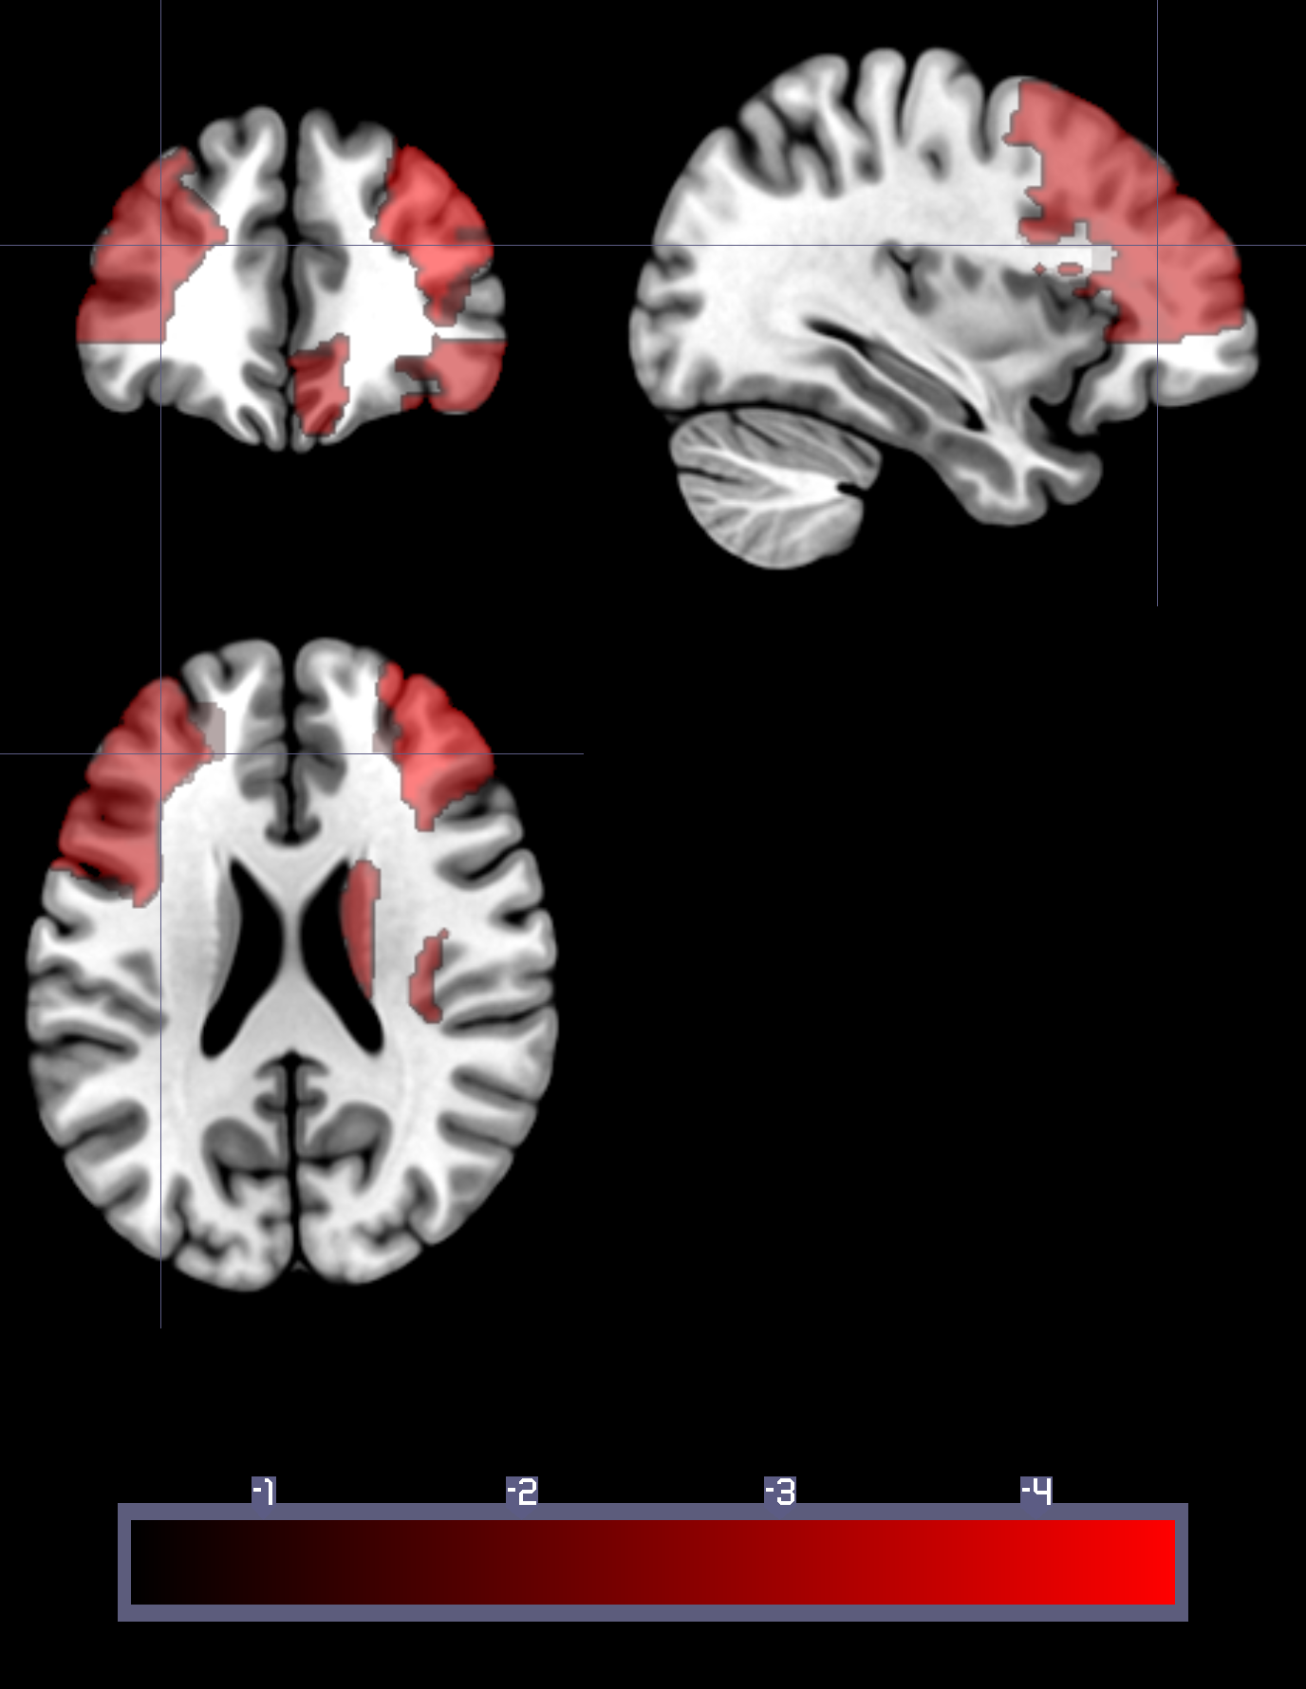

Figure2. T-map showing areas of increased gamma power in ET compared to PD.

**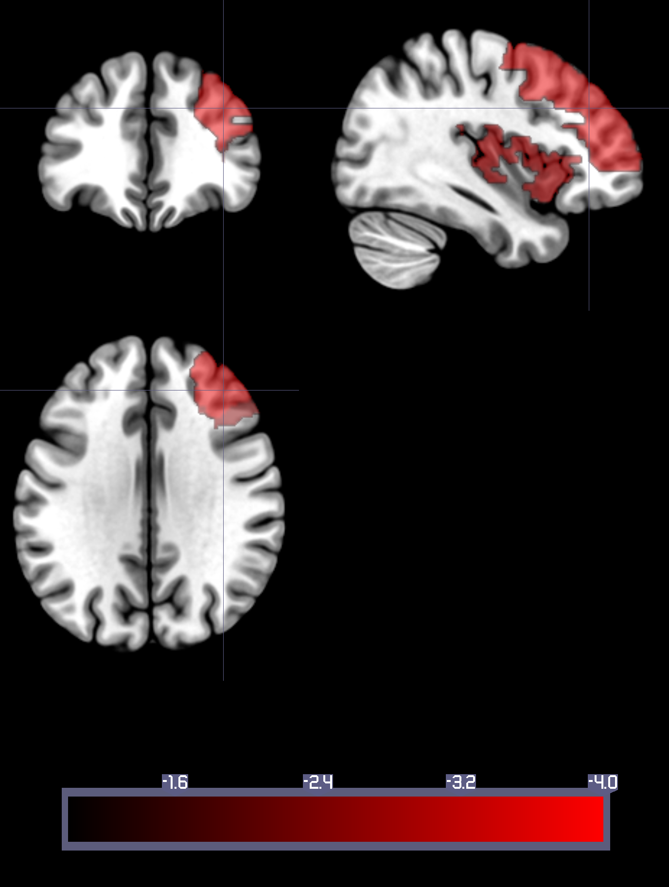**

Figure 3. Bar chart showing small world results for all groups/freq bands.

*Placeholder*

Figure 4: Scatter plot

Macintosh HD2:keeran:WorKfiles:Data:Benzi:ET_PDP:sw_alpha2_scatter.eps

Fig.5a: Correlation between upper alpha oscillatory power with MOCA score

Macintosh HD2:keeran:WorKfiles:Data:Benzi:ET_PDP:alpha2_power_moca_corr.eps

Fig.5b: Correlation between gamma small world metric and MOCA score Macintosh HD2:keeran:WorKfiles:Data:Benzi:ET_PDP:sw_moca_gamma_corr.eps